## SQL FUNDAMENTALS

**LIKE Operator**

**Introduction**

There are some cases where you don't know exactly the complete value you query. For instance, consider that you're trying to recall a student's county info from our student_info table. You know that the county's name starts with 'Wo'. In such cases, we use LIKE operator.  We combine LIKE operator with WHERE clause.

The general syntax is:

SELECT column_name(s)

FROM table_name

WHERE column_1 LIKE pattern;

After LIKE keyword, we construct a pattern. SQL provides two special characters for constructing patterns. These are also called wildcards.

* **Percent (%):**The % character matches any sequence of zero or more characters.
* **Underscore ( _ ):** The _ character matches any single character.

Patterns are case insensitive. Uppercase characters do match lowercase characters or vice versa. Let's show pattern matching in the following examples. You will find some pattern examples which can be used after the LIKE operator. Patterns are written in single quotes.

* 'Out%' pattern matches any string beginning with "Out" such as "Outro".
* 's%' pattern matches any string that starts with "s" such as "silk", "soup", etc.
* '%per%' pattern matches any string containing "per" such as "percentile" and "peeper".
* 's_n' pattern matches "son", "sun", etc.
* '__te' pattern matches "mate", "Kate", "kate", etc.

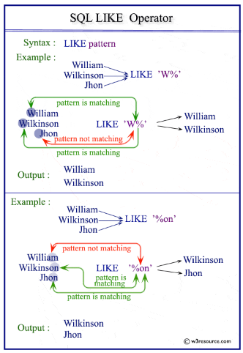

Now. Let's try to find a solution to our question at the beginning. We were trying to recall the county name which starts with "Wo". Since we don't know how many letters coming after "Wo", it's a good idea to use % wildcard here. Here is the pattern 'Wo%'.

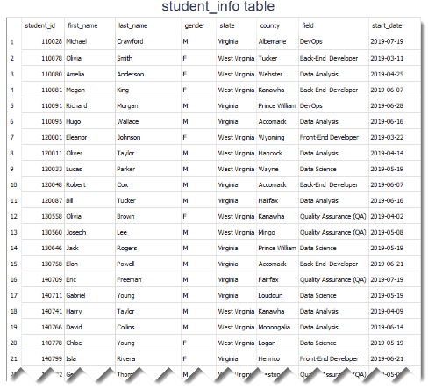

This is the query:

query :

SELECT *

FROM student_info

WHERE county LIKE 'Wo%';

Result table:  
  
output :

student_id first_name last_name gender state county field

     start_date

---------- ---------- ---------- ---------- ------------- ----------

    ------------------- ----------

170555 Megan Walker F West Virginia Wood Front-End

    Developer 2019-06-21

% wildcard matches with the letters 'od' in the Wood word. Remember that %wildcard matches any sequence of zero or more characters.

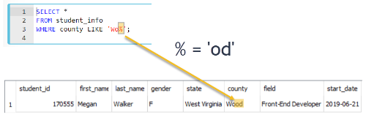

Since LIKE operator is case insensitive, you could write the pattern LIKE 'wo%' . Both patterns will produce the same results.

### Percent Character Example

In this part, we continue with another example using % wildcard.

Suppose that we try to find front-end and back-end developers in our student_info table. If we look at the **field** **column,**we see that the word "Developer" is found at the end of the each field value. So, what do you think the pattern will be?

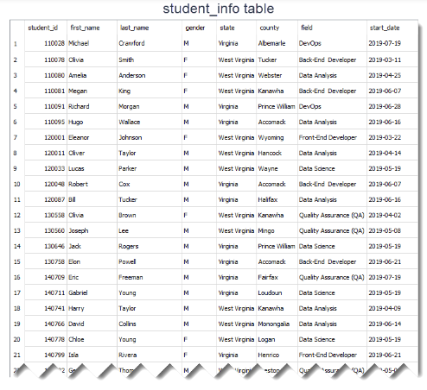

The pattern is '%Developer'. Herein % wildcard will include all the characters before the word "Developer". Let's write the query:

query :

SELECT *

FROM student_info

WHERE field LIKE '%Developer';

The output of the query:  
  
output :

student_id first_name last_name gender state county field

     start_date

---------- ---------- ---------- ------- ------------- ----------

    ------------------- ----------

110078 Olivia Smith F West Virginia Tucker Back-End

    Developer 2019-03-11

110081 Megan King F West Virginia Kanawha Back-End

    Developer 2019-06-07

120001 Eleanor Johnson F West Virginia Wyoming Front-End

    Developer 2019-03-22

120048 Robert Cox M Virginia Accomack Back-End

    Developer 2019-06-07

130758 Elon Powell M Virginia Accomack Back-End

    Developer 2019-06-21

140799 Isla Rivera F Virginia Henrico Front-End

    Developer 2019-06-21

150227 Chloe Fisher F Virginia Fairfax Back-End

    Developer 2019-07-18

150234 George Martinez M West Virginia Pocahontas Front-End

    Developer 2019-05-07

150246 Arthur Wright M West Virginia Monongalia Back-End

    Developer 2019-06-07

160021 Olivia Cooper F Virginia Bedford Front-End

    Developer 2019-06-21

170555 Megan Walker F West Virginia Wood Front-End

    Developer 2019-06-21

170566 Jack Morris M West Virginia Wetzel Front-End

    Developer 2019-06-28

There are 12 students whose field is Back-End Developer or Front-End Developer. We could write the pattern as '%Developer%'. This also returns the same result table. There is no character coming after the word "Developer". But remember % wildcard also matches zero characters.

In the previous part, we said that LIKE operator is case-insensitive. That means instead of '%Developer', we can write '%developer', '%DEVELOPER' even '%DEveloper'. All those patterns will match "Back-End Developer" or "Front-End Developer".

However, if you want to make LIKE operator case-sensitive, we need to use PRAGMA statement as follows:

PRAGMA case_sensitive_like = true;

Write the query again using PRAGMA statement and pattern '%developer'.  
  
query :

PRAGMA case_sensitive_like = true;

SELECT *

FROM student_info

WHERE field LIKE '%developer';

The output of the new query is a blank table.  
  
output :

1

In case you change the setting of LIKE operator from case-insensitive to case-sensitive, you need to construct the pattern as '%Developer' to match.